PRACTICAL NO : 3

Aim : Study and Implementation of Software as a Service Theory :

SaaS is also known as "**On-Demand Softwaíe**". It is a softwaíe distíibution model in

which seívices aíe hosted by a cloud seívice píovideí. ľhese seívices aíe available to end-useís oveí the inteínet so, the end-useís do not need to install any softwaíe on theií devices to access these seívices.

Output

1. Go to Asure Portal Select Virtual Machine

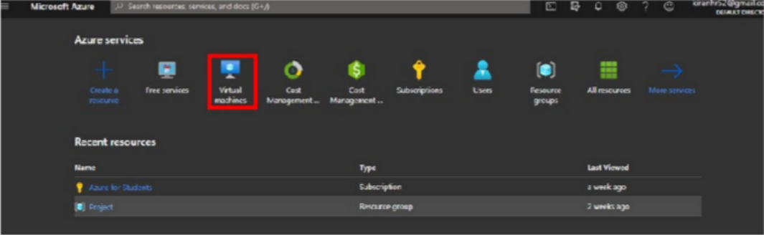

1. Create a Resource Group

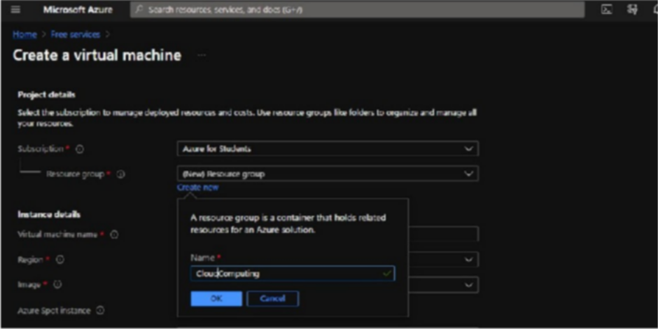

1. Select OS and Fill Other Necessay Information

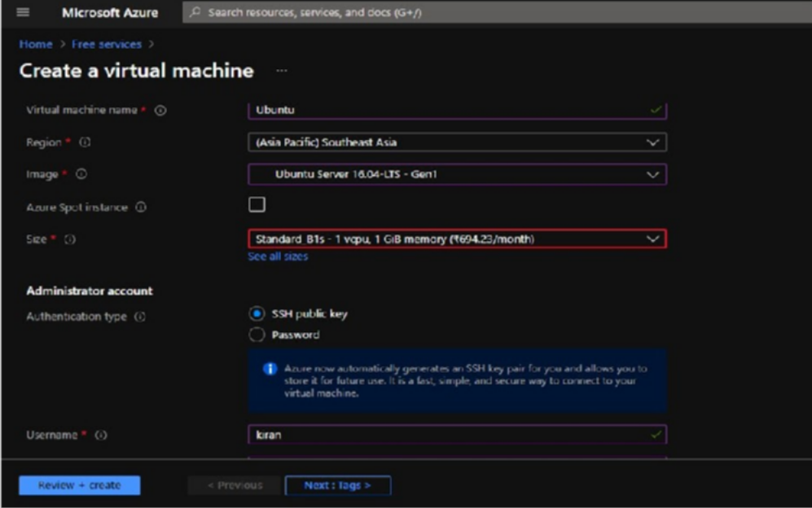

1. Generate a Public Key Using Putty Gen

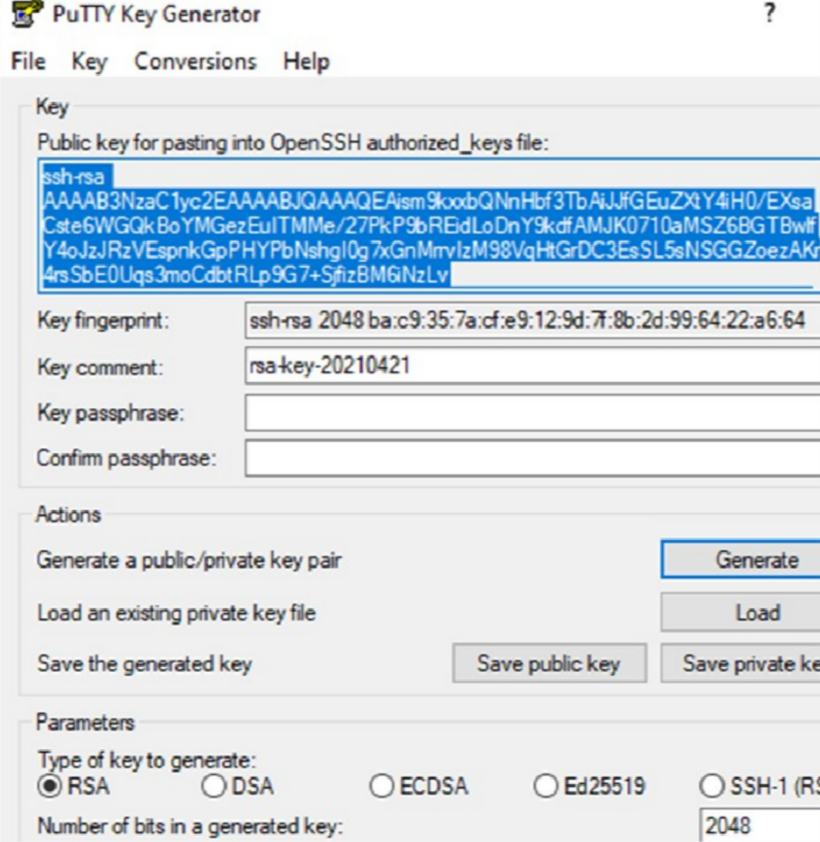

1. Now save the generated public and private key into your computer
2. Copy and paste the generated public key into azure portal and Click on Reviwe + create Button

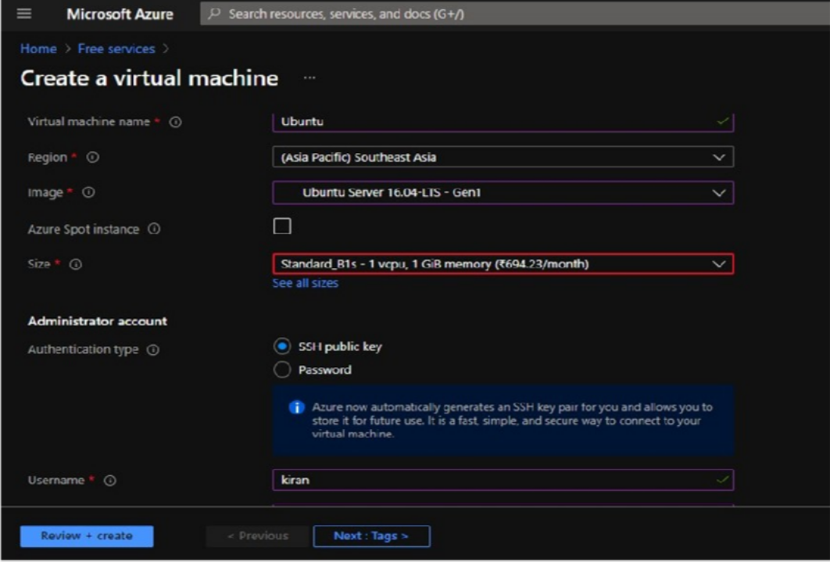

1. Click on Create Button

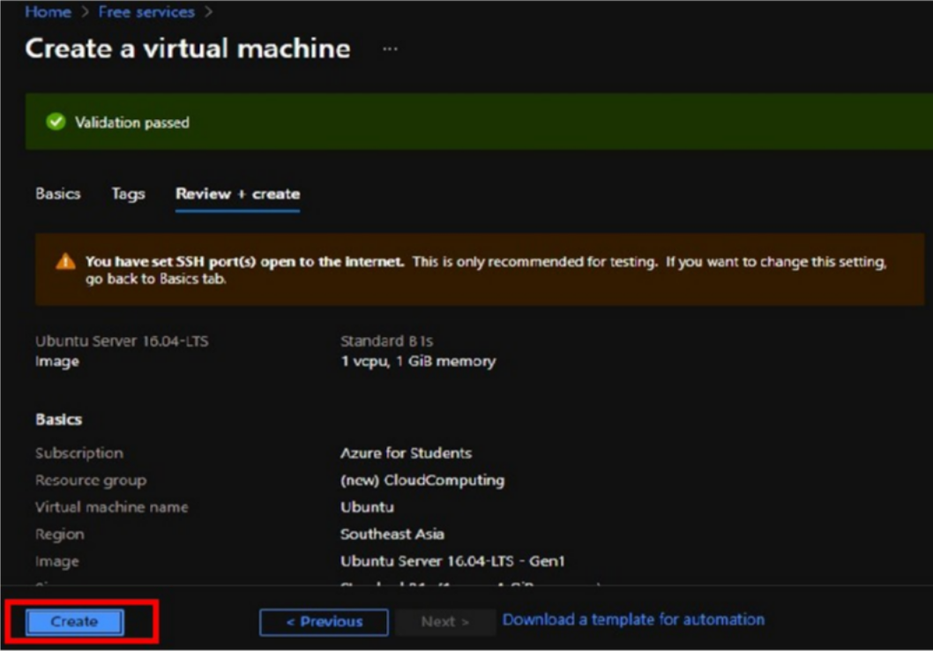

1. Our Virtual machine has been created . Now click on got resource

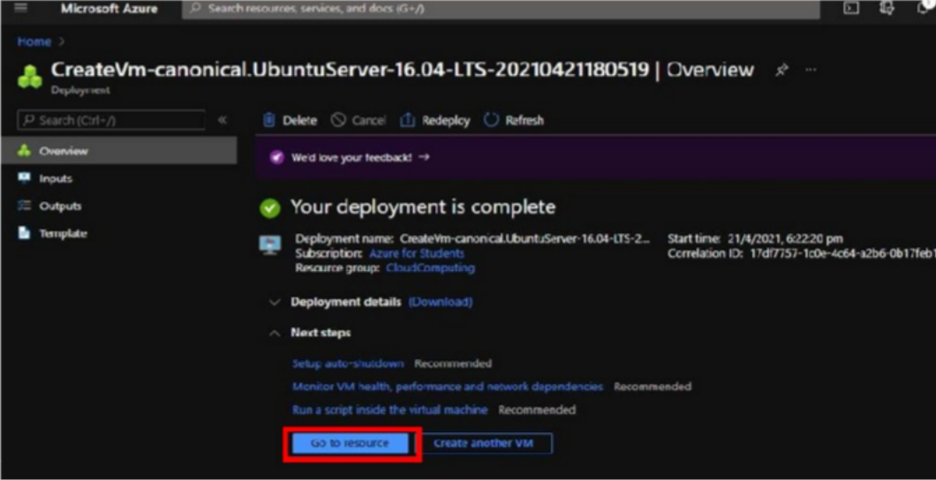

1. Copy the public IP of Your Machine and Paste in the putty software

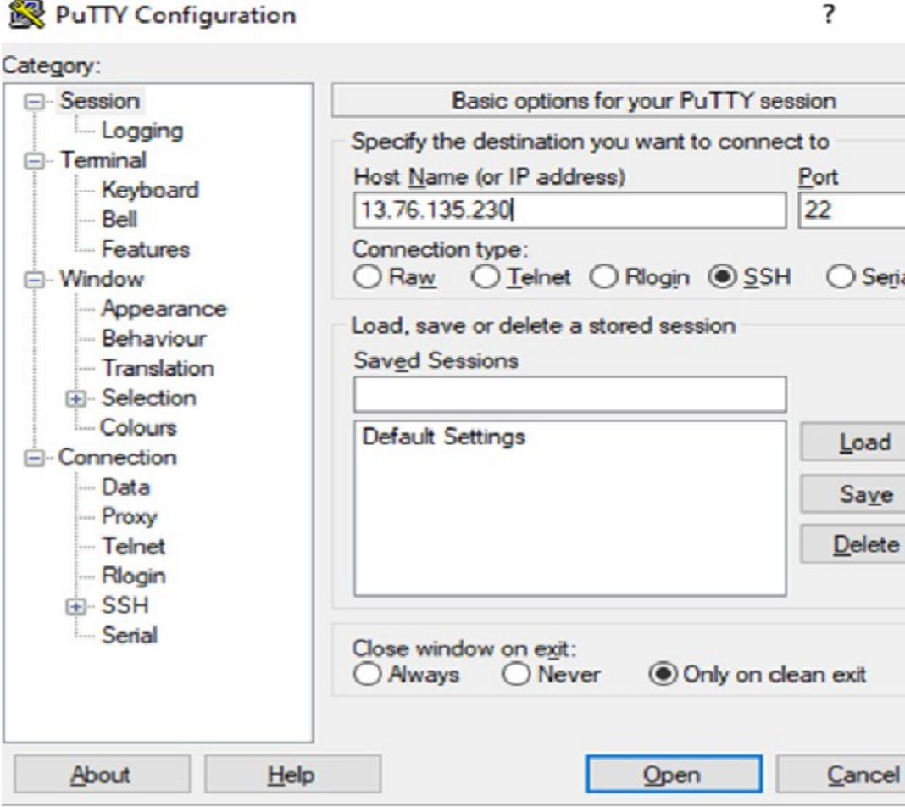

10 ) We have Successfully created the VM

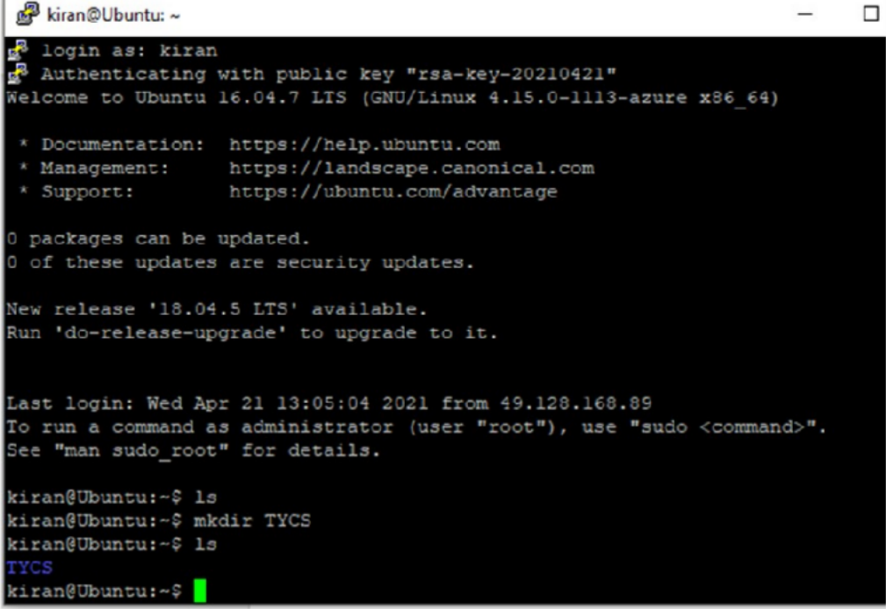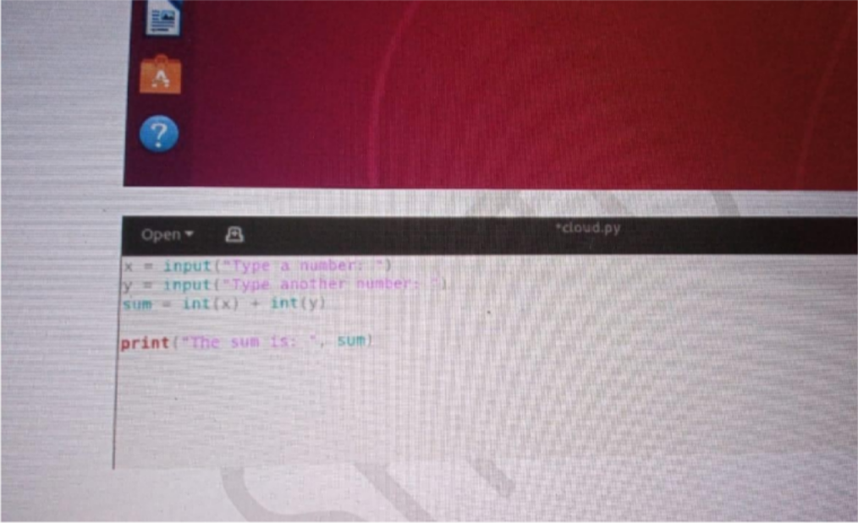

Conclusion : Successfully Performed Saas